**Area & Perimeter**

**Homework Helper**

MGSE4.MD.3 Apply the area and perimeter formulas for rectangles in real world and mathematical problems. For example, find the width of a rectangular room given the area of the flooring and the length, by viewing the area formula as a multiplication equation with an unknown factor.

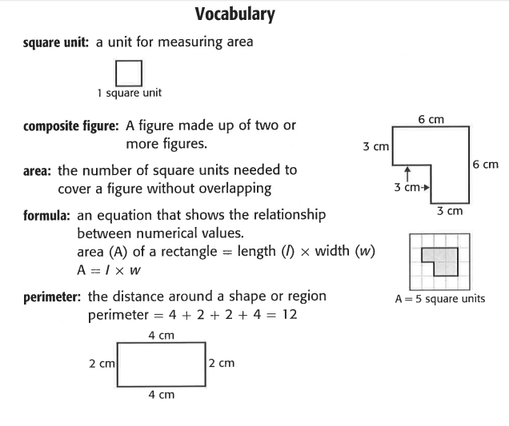

Students developed understanding of area and perimeter in 3rd grade by using visual models. While students are expected to use formulas to calculate area and perimeter of rectangles, they need to understand and be able to communicate their understanding of why the formulas work. The formula for area is I x w and the answer will always be in square units. The formula for perimeter can be 2 l + 2 w or 2 (l + w) and the answer will be in linear units. This standard calls for students to generalize their understanding of area and perimeter by connecting the concepts to mathematical formulas. These formulas should be developed through experience not just memorization.

Examples:

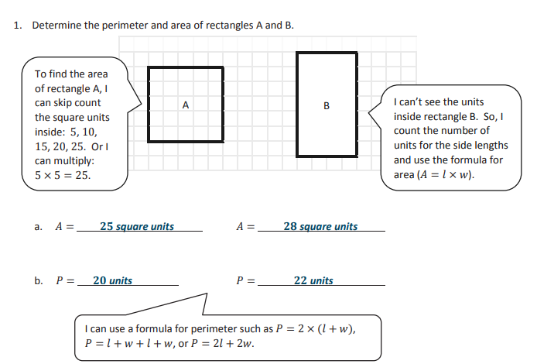

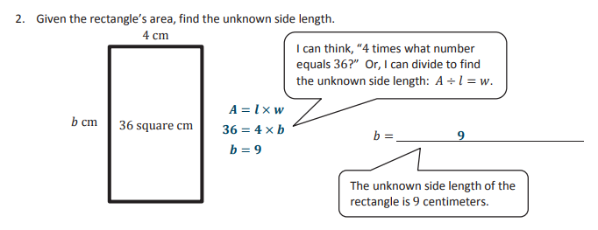

MGSE4.MD.8 Recognize area as additive. Find areas of rectilinear figures by decomposing them into non-overlapping rectangles and adding the areas of the non-overlapping parts, applying this technique to solve real world problems.

The area of a shape is defined as the number of square units that cover a closed figure. For most of the shape that we will be dealing with there is a formula for calculating the area. In some cases, our shapes will be made up of more than a single shape. In calculating the area of such shapes, we can just add the area of each of the single shapes together. We will start with the formula for the area of a rectangle. Recall that a rectangle is a quadrilateral with opposite sides parallel and right interior angles.

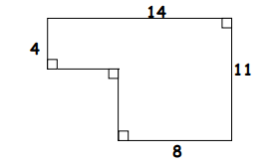

Solution: This figure is not a single rectangle. It can, however, be broken up into two rectangles. We then will need to find the area of each of the rectangles and add them together to calculate the area of the whole figure. There is more than one way to break this figure into rectangles. We will only illustrate one below.

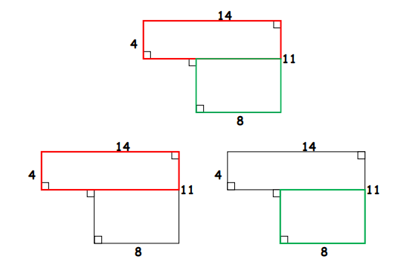

We have shown above that we can break the shape up into a red rectangle (figure on left) and a green rectangle (figure on right). We have the lengths of both sides of the red rectangle. It does not matter which one we call the base and which we call the height. The area of the red rectangle is A = bh = 4 × 14 = 56 We have to do a little more work to find the area of the green rectangle. We know that the length of one of the sides is 8 units. We had to find the length of the other side of the green rectangle when we calculated the perimeter in Example 1 above. Its length was 7 units.

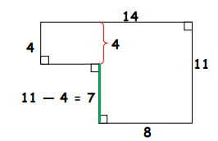

Thus the area of the green rectangle is A = bh = 8 × 7 = 56. Thus the area of the whole figure is area of red rectangle + area of green rectangle = 56 + 56 = 112. In the process of calculating the area, we multiplied units times units. This will produce a final reading of square units (or units squared). Thus the area of the figure is 112 square units. This fits well with the definition of area which is the number of square units that will cover a closed figure.